**Formative Assignment 2**

1. Common Content

a. Header



in this header there is a logo, navbar, toggle button light & dark to change the theme on the website and there is also a login button to access the sign in and sign up page

b. Footer

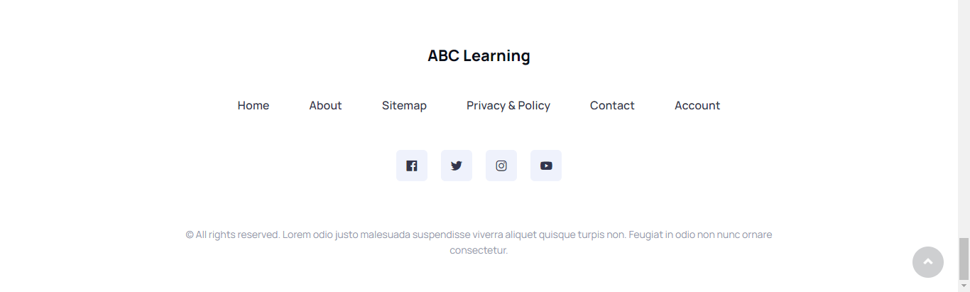

Inside the footer there is also a logo in the middle, and below it is also a navbar that points to the home page, about page, sitemap, privacy & policy, contact, and accounts to access several pages on the website.

c. Navigation

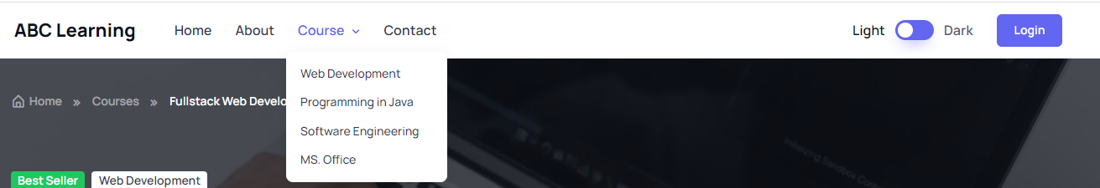

in the navigation there is also a home, about, dropdown course which contains some of the most popular courses, as well as contacts

2. Home Page



This home page contains some of the information on the website, in the first section we will present it with the hero header and the tagline on the website, then in the next section we will present the course category and display card view courses, in the third section the user will be presented with several steps "how is it work?", then the "What You Get" section in this course, and there are several testimonials from examples of students who have studied in this course, of course added with the logos of several companies or university institutions who have worked with this course so that users can have more confidence in this course, after that there is an additional image and a sign up section, and finally there is a footer section below

3. About Us Page / Profile Page

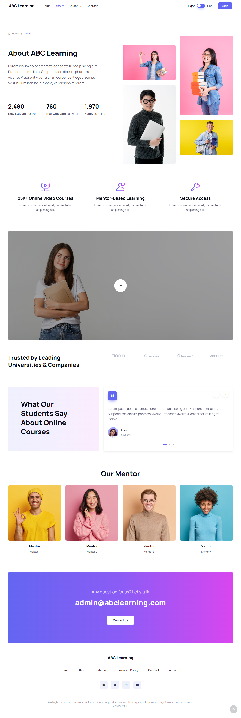

This about page contains detailed information about the organizers of the course, starting from New Student per Month, New Graduate per Week, Happy Learning, Trusted by Leading Universities & Companies with logos, student testimonials, and several teaching mentors, and before the footer there is an email main organizer of the couse

4. Contact Us Page (Develop 1 Html page)

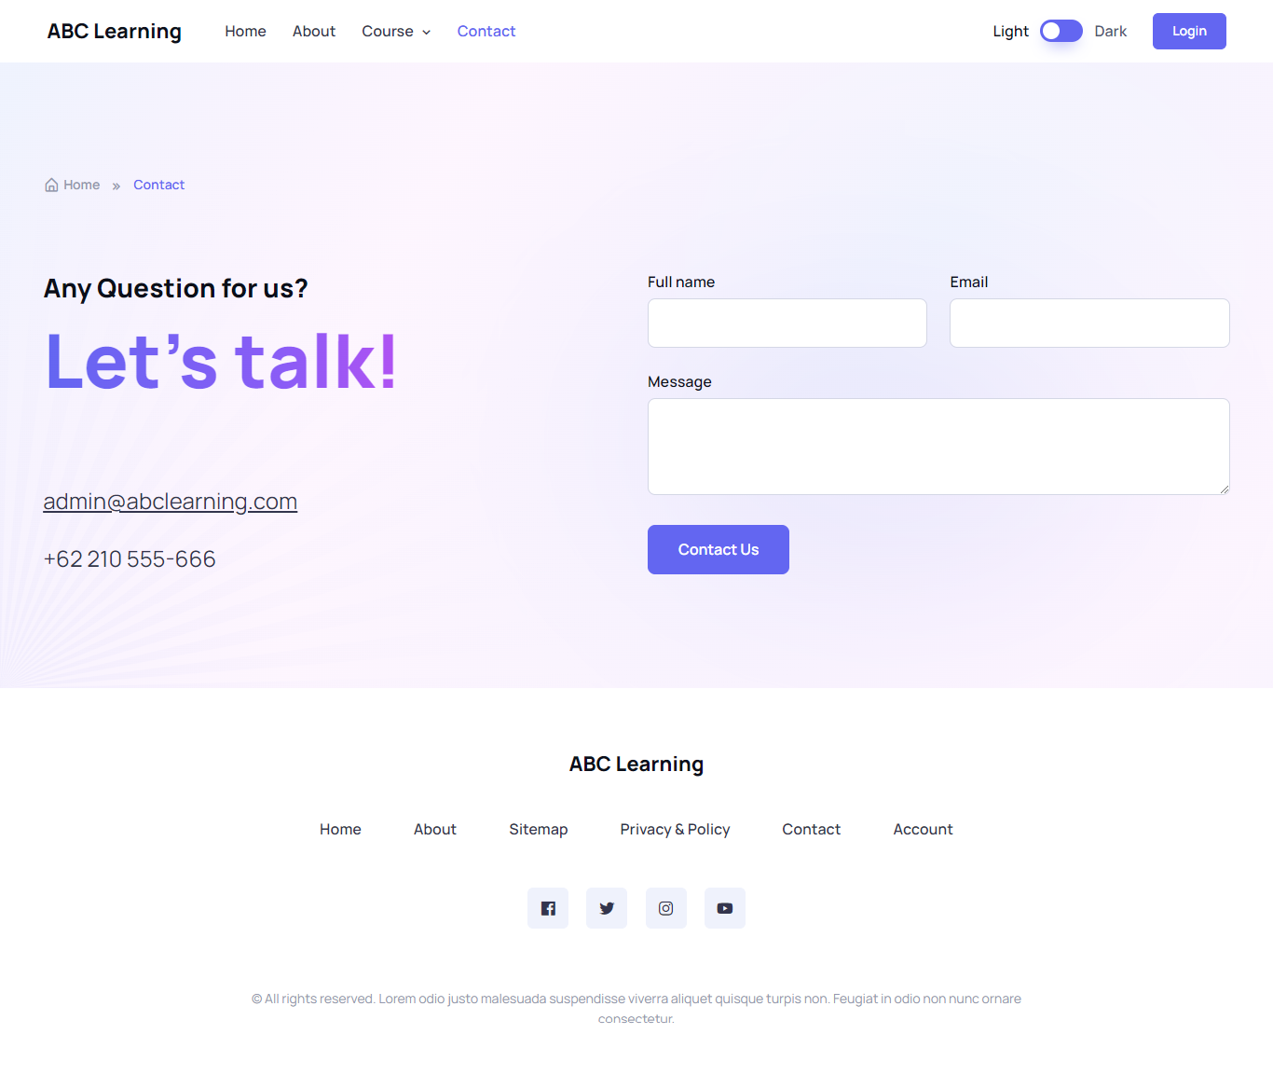

the contact us contains the headline "Any Question for us?

Let's talk!", email and contact numbers. There is also a complaint or message form for admins

5. 4 Course Details Page ( 1 for each course)









In the details of this course there are 4 pages with different details, the first page contains course details for web development, the second is programming in Java, the third is software engineering, and the last is the MS Office course, these four pages have more or less the same details, namely there is a course title, course description, course includes, program details, button schedule, about mentors, and testimonials from students who bought the course, and added a similar course section

6. 4 Course Schedule Page (1 for each course)



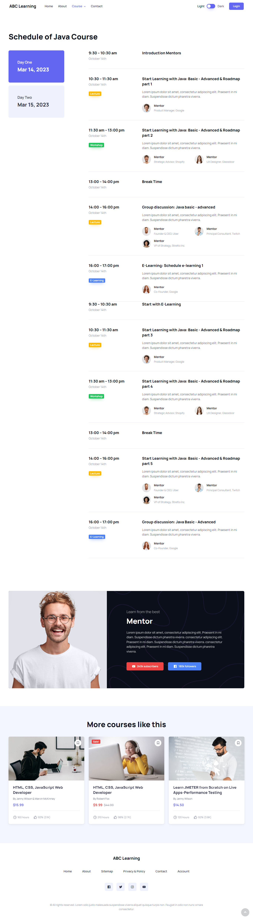





not much different from the course detail page in the previous point, here there are also 4 different schedules for each course, and then below it is also about the mentor

7. Sitemap Page (Develop 1 HTML page)

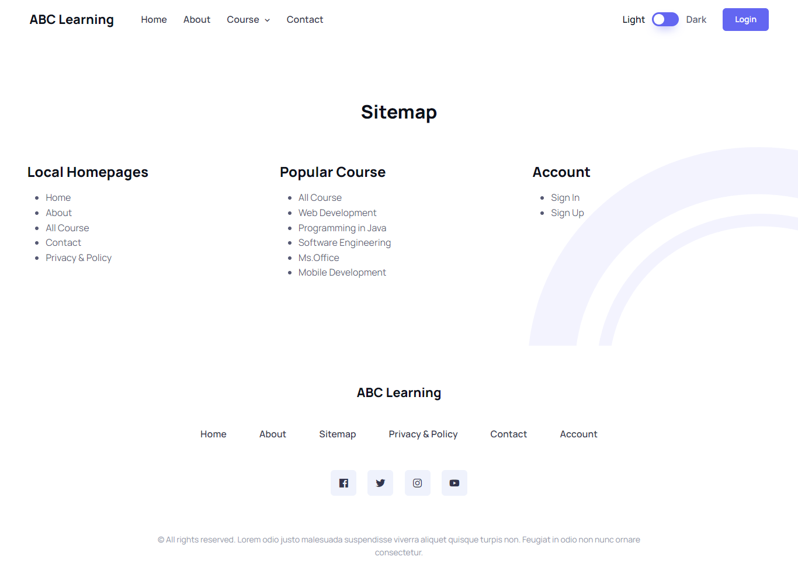

The sitemap page is a guide for all the pages on the website, on this website there are local homepages, popular courses, and accounts. you can find many pages here which are presented with a list

8. Privacy Policy Page (Develop 1 HTML page)

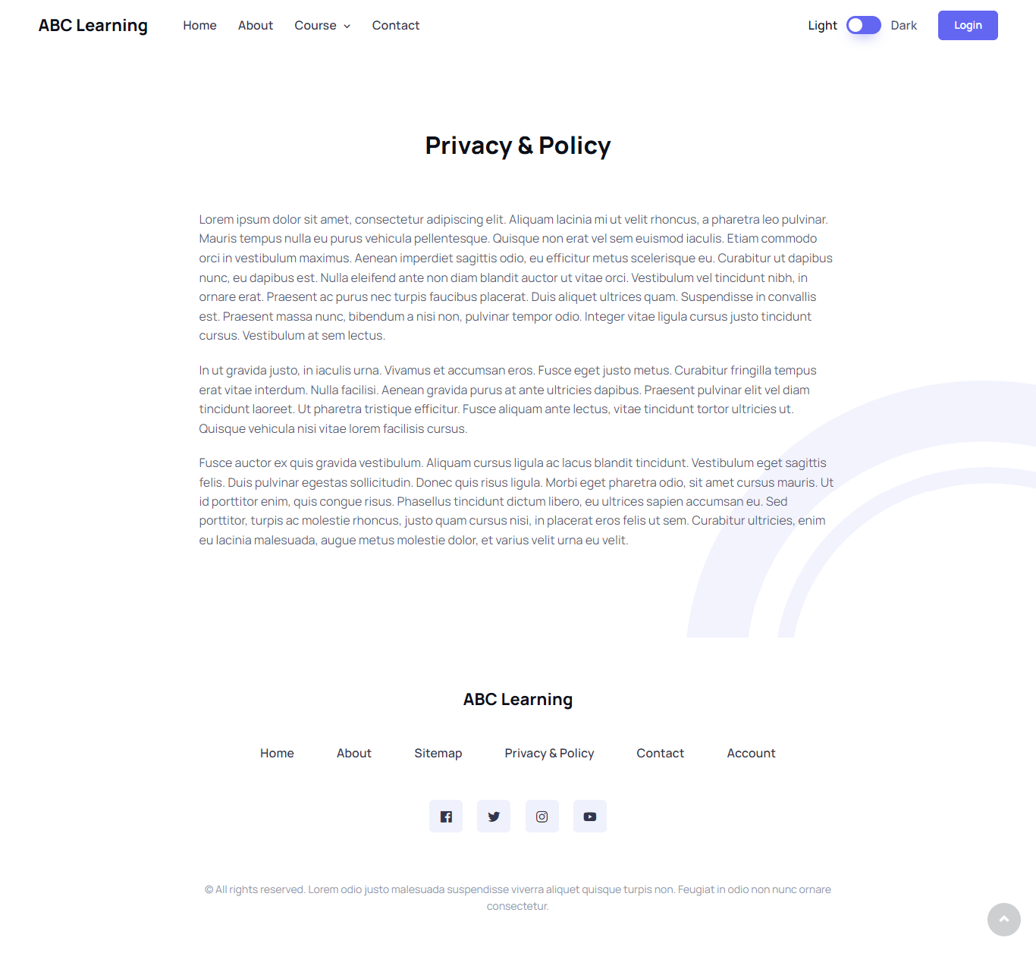

on this privacy & policy page there is only a provision that is on the website in detail and complete.

**Testing and Validation**

Web app testing is a methodology of software testing & quality assurance process wherein bugs and errors that may lead to web app failure are identified and fixed.

Web apps are accessed via a wide range of web browsers, OSs, and network types. There are many benefits for digital businesses leveraging web application testing, which ultimately ensures the end users get the best possible UX.

Web application testing ensures no bugs sneak into the final production and the final web app release is bug-free.

**Types of testing and validation techniques used?**

1. Usability(10TC)
2. Functional(10TC)
3. Compatibility(10TC)
4. Performance(10TC)
5. Responsive(10Tc)
6. Software specify(Tool)

|  |  |  |  |  |  |  |  |  |
| --- | --- | --- | --- | --- | --- | --- | --- | --- |
| Test Scenario ID | | Usability | | | | Test Case ID | | Usability |
| Test Case Description | | Usability | | | | Test Priority | | High |
| Pre-Requisite | | N/A | | | | Post-Requisite | | N/A |
| Test Execution steps: | | | | | | | | | |
| S.No | Action | Inputs | Expected Output | Actual Output | Test Browser | | Test Result | Test Comments | |
| 1. | Launch Application | https://learning-center-wheat.vercel.app/ | ABC Learning Center | ABC Learning Center | Chrome  Firefox  M. Edge | | pass | Launch Successful | |
| 2. | Web page content | https://learning-center-wheat.vercel.app/ | ABC Learning Center | ABC Learning Center | Chrome  Firefox  M. Edge | | Pass | Web page content correct | |
| 3. | All fonts | https://learning-center-wheat.vercel.app/ | ABC Learning Center | ABC Learning Center | Chrome  Firefox  M. Edge | | Pass | All font correct | |
| 4. | Navigation | https://learning-center-wheat.vercel.app/ | Home, About, Course with dropdown, Contact | Home, About, Course with dropdown, Contact | Chrome  Firefox  M. Edge | | Pass | Navigation correct | |
| 5. | Check the site on different resolutions | https://learning-center-wheat.vercel.app/ | Responsive all device | Responsive all device | Chrome  Firefox  M. Edge | | Pass | Responsive all device correct | |
| 6. | Scroll website | All pages | Smooth scroll on website | Smooth scroll on website | Chrome  Firefox  M. Edge | | Pass | Scroll all pages correct | |
| 7. | Enter valid email & any password sign in | Email id: [invalid@abclearnning.com](mailto:invalid@abclearnning.com)  Password: **** | The email address does match any account and hide any password should be **** | The email address does match any account and hide any password should be **** | Chrome  Firefox  M. Edge | | Pass | Login enter valid email and password valid | |
| 8. | Title should be display on each web page | https://learning-center-wheat.vercel.app/ | ABC Learning Center | Online Learning center for education | ABC Learning Center | Online Learning center for education | Chrome  Firefox  M. Edge | | Pass | All title display on each web page | |
| 9. | Sitemap page should be connect for list page | https://learning-center-wheat.vercel.app/sitemap.html | All page connect from sitemap | All page connect from sitemap | Chrome  Firefox  M. Edge | | Pass | Sitemap work | |
| 10. | Broken link and image | https://learning-center-wheat.vercel.app/ | All image and link should be show and didn’t broken | All image and link should be show and didn’t broken | Chrome  Firefox  M. Edge | | Pass | All image and link didn’t broken | |

|  |  |  |  |
| --- | --- | --- | --- |
| Test Scenario ID | Functional | Test Case ID | Functional |
| Test Case Description | Functional | Test Priority | High |
| Pre-Requisite | NA | Post-Requisite | NA |
| Test Execution steps: | | | |

|  |  |  |  |  |  |  |  |
| --- | --- | --- | --- | --- | --- | --- | --- |
| S. NO | Action | Inputs | Expected Output | Actual Output | Test Browser | Test Result | Test comment |
| 1. | All input fields | fill out the form completely | The form input should be cannot error | The form absolutely works | Chrome  Firefox  M. Edge | Pass | all forms can be filled correctly |
| 2. | functionality of the buttons available | The function of the button corresponds to the direction of the a href tag | The button should be work base on tag a href | all buttons work normally | Chrome  Firefox  M. Edge | Pass | all buttons function normally and run smoothly |
| 3. | Privacy Policy & FAQ is clearly defined and should be available for users. | Privacy & policy page must be clearly visible to users | users can understand privacy & policy based on what they read | privacy & policy page works well and is understandable for users | Chrome  Firefox  M. Edge | Pass | page and description in easy to understand by the user |
| 4. | the Java script is properly working in different browsers | all javascript functions run normally in every browser user | user can use javascript function in every browser | the javascript function runs very well in every browser | Chrome  Firefox  M. Edge | Pass | javascript works very well for every user's browser |
| 5. | the system should not display the error message | all systems work properly and do not produce errors in every corner of the website | every user does not get an error message when accessing any page on the website | the existing system does not display an error message on each user's browser | Chrome  Firefox  M. Edge | Pass | the system works very well and displays no error messages |
| 6. | Functional Image | every image loaded does not display a blank document | Users can view images that have been loaded by the website in each user's browser | images can be loaded very normally and do not experience blanks during the loading process | Chrome  Firefox  M. Edge | Pass | function on the image runs very well |
| 7. | Functional Link | each link can be directed directly to the intended link | Users can easily access the list of links available on the website | the link is very well directed according to the output on the website | Chrome  Firefox  M. Edge | Pass | every link runs very normally |
| 8 | Functional Sidebar | when the user accesses via mobile, the user will get a navigation menu in the form of a sidebar on the side | responsive functions in the navigation menu can work well when users use mobile | the function on the navigation menu in the form of a mobile sidebar works very well | Chrome  Firefox  M. Edge | Pass | sidebar function works very well |
| 9. | Navigation Menu | users can very easily access and understand the navigation menu on the website | the navigation menu function works very well and is responsive on each user's browser | navigation on each user's browser runs well and is responsive | Chrome  Firefox  M. Edge | Pass | the navigation menu is responsive and works very well |
| 10. | Icon functional | Users can see various kinds of icons available on the website | users can very easily see the icons on the website without any errors | every existing icon can run normally in every browser without errors | Chrome  Firefox  M. Edge | pass | icon works very well |

|  |  |  |  |
| --- | --- | --- | --- |
| Test Scenario ID | Compatibility | Test Case ID | Compatibility |
| Test Case Description | Compatibility | Test Priority | High |
| Pre-Requisite | NA | Post-Requisite | NA |
| Test Execution Steps: | | | |

|  |  |  |  |  |  |  |  |
| --- | --- | --- | --- | --- | --- | --- | --- |
| S.No | Action | Inputs | Expected Output | Actual Output | Test Browser | Test Result | Test Comments |
| 1. | website in different browsers | Users can access the website using different types of browsers | users can access the website using different browsers without errors | each user can run the website with a different browser without errors | Chrome  Firefox  M. Edge | Pass | Website runs on different browsers work |
| 2. | ensure the website is displaying properly | ensure the website displays properties for different types of browsers | users can display properties with different browsers on the website without error | the website successfully displays properties in different browsers without any errors | Chrome  Firefox  M. Edge | pass | Displaying property for different browsers work |
| 3. | HTML version being used is compatible with appropriate browser versions | ensure the HTML version matches the version supported by each browser | users can access the HTML version that is supported by the browser | the HTML version on each browser runs very smoothly | Chrome  Firefox  M. Edge | pass | the user can be sure to access the HTML version that is supported by the browser |
| 4. | images display correctly in different browsers | images can be seen by users in different browsers | users can interact with the images provided by a website | the images on a website run smoothly and there are no errors | Chrome  Firefox  M. Edge | pass | images can run with different procedures |
| 5. | fonts are usable in different browsers | All fonts can be accessed through different browsers | users are ensured to be able to access fonts in every browser without errors | the browser can access all the fonts on the website without error | Chrome  Firefox  M. Edge | pass | all fonts run smoothly in each different browser |
| 6. | java script code is usable in different browsers | functions in javascript can run smoothly in every different browser in each story | ensure that JavaScript can be accessed by users through different browsers | javascript is working normally plus an error occurs in every user process | Chrome  Firefox  M. Edge | pass | JavaScript is available to different browser users |
| 7. | Animation CSS is usable in different browsers | the animation function in CSS can also be accessed by users through different browsers | ensure that users can access animations in CSS on the website using different browsers | the animation function in CSS runs very well on every user's browser | Chrome  Firefox  M. Edge | pass | CSS animations are available to every Browser user |
| 8. | the website works using different operating systems | users can run the website smoothly using different OS | ensure that the website can run normally on each different OS | the website runs normally for users on different OS | Chrome  Firefox  M. Edge | pass | Users can access websites with different operating systems |
| 9. | all functions on the website work with different browsers | all functions on the website run normally for users on different OS and different browsers | every function on the website is available to users of different browsers | all functions on the website run normally and there are no problems when accessing | Chrome  Firefox  M. Edge | pass | all function works very well |
| 10. | all link function works on different browsers | Users can access links on websites using different browsers | ensure that users can access links on every page of the website smoothly | All links on the website can be accessed by different browser users | Chrome  Firefox  M. Edge | pass | the link function on different browsers runs very smoothly |

|  |  |  |  |
| --- | --- | --- | --- |
| Test Scenario ID | Performance | Test Case ID | Performance |
| Test Case Description | Performance | Test Priority | High |
| Pre-Requisite | NA | Post-Requisite | NA |
| Test Execution Steps: | | | |

|  |  |  |  |  |  |  |  |
| --- | --- | --- | --- | --- | --- | --- | --- |
| S.No | Action | Inputs | Expected Output | Actual Output | Test Browser | Test result | Test Comments |
| 1. | Verify response time is not more than 4 secs | make sure the user can access the website more than 4 seconds | users can access the website very quickly and stably | the website runs smoothly and quickly in less than 4 seconds | Chrome  Firefox  M. Edge | pass | website can access less than 4 seconds |
| 2. | Verify response time of the Application Under Load is within an acceptable range when the network connectivity is slow | ensure that the website can run stably when the user's connection is unstable | makes it easier for users to access websites with unstable connections | the website can run stably without errors when the user's connection is unstable | Chrome  Firefox  M. Edge | pass | the website runs very well when the connection is low |
| 3. | Check the maximum number of users that the website can handle before it crashes. | ensure that How many users can access the website simultaneously | the website can run normally when many users are accessing the website at the same time | the website runs very normally when many users access the website | Chrome  Firefox  M. Edge | pass | the website does not crash when many users access the website |
| 4. | ensure that the website can run smoothly when you first access the website | ensure that users can access the website very fast and stable for the first time | users can access the website for the first time stably and very quickly | users can access the website the first time very quickly | Chrome  Firefox  M. Edge | pass | initial access to the website is very fast |
| 5. | ensure that users can quickly access responsive websites | ensure that when the user is using a mobile or tablet the website will be very fast when it is loading | users feel very comfortable when accessing the website via mobile or tablet | when a user uses a mobile or tablet the user can access the website normally and quickly | Chrome  Firefox  M. Edge | pass | users can quickly access when responsive the websites |
| 6. | ensure that the load accessed on the website is lighter | ensure that each page that will be accessed by users does not crash or can run normally | users can access each page normally without any errors at the initial access | the website runs very well on every page that will be loaded | Chrome  Firefox  M. Edge | pass | the website loads the page very well |
| 7. | the website can run smoothly when the connection is low | when a user has an unstable connection, the user can load the website very quickly | ensure that users do not have problems when they have an unstable connection | users very easily access the website when the user has a low connection | Chrome  Firefox  M. Edge | pass | the website can run a low connection test |
| 8. | stabilize images that have been loaded on the website so that the website is faster | every image can run smoothly when the user accesses the website without errors | users don't get errors in the images that are loaded and don't burden the website when users will access the website | images are easily loaded when the user is accessing the website | Chrome  Firefox  M. Edge | pass | Stabilizing the images loaded by the website works really well |
| 9. | CSS functions can run normally when minified | when the CSS function is minimized the website can run smoothly for the users | users can very easily access the website without any obstacles when the CSS function is minimized | users can access websites that have minimized the CSS function to make it look lighter | Chrome  Firefox  M. Edge | pass | the website runs very normally when the CSS function is minimized |
| 10. | javascript can run smoothly when the user's connection is unstable | when a user accesses a website with an unstable connection the javascript function can run very smoothly | users will not experience problems with javascript when accessing websites with unstable connections | the user successfully accesses the website with javascript functions that run normally on an unstable connection | Chrome  Firefox  M. Edge | pass | javascript managed to run smoothly when the connection is unstable |

|  |  |  |  |
| --- | --- | --- | --- |
| Test Scenario ID | Responsive | Test Case ID | Responsive |
| Test Case Description | Responsive | Test Priority | High |
| Pre-Requisite | NA | Post-Requisite | NA |
| Test Execution Steps: | | | |

|  |  |  |  |  |  |  |  |
| --- | --- | --- | --- | --- | --- | --- | --- |
| S.No | Action | Inputs | Expected Output | Actual Output | Test Browser | Test Result | Test Comments |
| 1. | Correct display of all website images on the devices with different screen sizes | users can be sure to access image websites with different screen sizes | users can access the image website via mobile or tablet with different screen sizes without errors | users can access the image website smoothly with different screen sizes without any errors | Chrome  Firefox  M. Edge | Pass | the size of the image on the website changes when the user accesses it using a different screen size |
| 2. | The size of images, text and other website blocks should be proportionally changed in accordance with the screen sizes | users can access properties on the website with different screen sizes | there are no errors for each property on the website when users access it using different screen sizes | the properties on the website do not change when the user accesses using different sized screens | Chrome  Firefox  M. Edge | Pass | all properties on the website run well and normally with different screen sizes |
| 3. | The color of all site elements should be preserved, despite the extension and characteristics of the screen. | the basic color of the website does not change when the user accesses it using a different screen size | users can access all the colors in the website equally | the colors on the website do not change when the user accesses through different screen sizes | Chrome  Firefox  M. Edge | Pass | The colors on the website are suitable for different screen sizes |
| 4. | When a user enters input, it should be displayed correctly with the size of pins, font, and tabs | each user input must be correct and appropriate for each different screen size | users can input according to their input correctly and with different screen sizes | when the user inputs data in the form column there is no error when the user uses different screen sizes | Chrome  Firefox  M. Edge | Pass | displayed correctly with the size of pins, font, and tabs |
| 5. | The page should be scrolled without any problems and failures. | every page on the website must be scrollable without errors occurring on each page | user can easily scroll each page without error | scroll on each page is successful without any error | Chrome  Firefox  M. Edge | Pass | the user can very easily scroll through the page and no errors occur |
| 6. | all fonts do not change on different screen sizes | each font does not change when the user accesses it using a different screen size | it can be ascertained that the user has the same output when the user accesses the website with a different screen size | each font does not change when the user accesses it with a different screen size | Chrome  Firefox  M. Edge | Pass | all fonts are successful and accessible to the users |
| 7. | the navigation menu has a toggle button when users access the website via mobile or tablet | when the user accesses with a smaller screen size, there are buttons for the navigation menu | users very easily access the menu on the website using a smaller screen size | the use of the navigation menu button on a small screen size is successful | Chrome  Firefox  M. Edge | Pass | users very easily access the website with a small screen size |
| 8. | the image has no error when different screen sizes | when the user accesses the image with a different screen size there is no error | every user who accesses with a different screen size does not have an error on every image on every page | the user manages to access the website using different screens without errors occurring on each image | Chrome  Firefox  M. Edge | Pass | the uploaded image does not have an error on every page on the website with different screen sizes |
| 9. | form fields change when users access websites with different screen sizes | when a user accesses a website with different screen sizes the form fields will experience a layout change | form fields can change when users access the website with different screen sizes | the form fields change successfully when the user accesses using different screen sizes | Chrome  Firefox  M. Edge | Pass | the form fields work successfully without any error with different screen sizes |
| 10. | the icon does not change when the user accesses the website with a different screen | when the user accesses screens of different sizes, the icons on the website don't change | users can also access the same icon when the user accesses the website using a different screen size | the icon does not change when the user accesses the website using different screen sizes | Chrome  Firefox  M. Edge | Pass | icons on the website run smoothly and according to different screen sizes |

